Significance
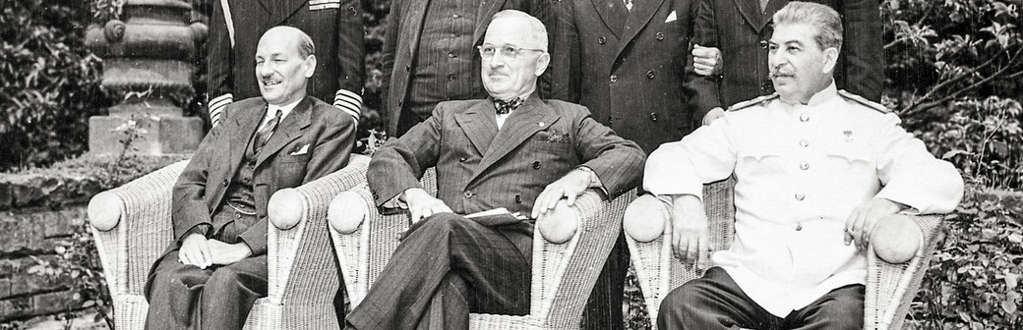Photo from the Potsdam Conference in Germany, showing Clement Attlee, Harry Truman and Josef Stalin. Public Domain. Source: https://commons.wikimedia.org/wiki/File:Potsdam_Conference_group_portrait,_July_1945.jpg

Some events, ideas or people have had such a long-lasting impact on the world that they could be significant. Not all things are significant for the same reasons as other things.

Significance is the measure of the importance that is assigned to events, developments, people, groups and locations. Something is considered to be significant if it caused an important change in history.

Discovering an event’s causes and its consequences helps work out if an event is significant or not.

Assessing Significance

Example questions for assessing Significance:
- What did this person do that had never been done before?
- What impact did the person or event have on people?
- How did people in the past view this person, event, location or change?
- What changed as a result of this person, idea or event?
- How important were the consequences of this person or event?
- Why is it still talked about today?
- How many lives were affected?

